**Lab 3: Bugs in the Air: Temperature and Growth**

(20 points)

**🡪This lab should be started during Week Three**

This lab will require that you have on hand at least 12 Petri dishes already filled with a nutrient agar. If you live at a great distance, contact your instructor to make arrangements to receive supplies.

**Objectives:**

* To discover the distribution of airborne fungi and bacteria in your home.
* To learn the effect of length of time exposure on the growth of bacteria and fungi.
* To examine the microbes growing in your mouth and in your nose.
* To learn the effect of temperature on the growth of bacteria.
* To make hypotheses and state whether the experimental data support the hypotheses.

**What to do:**

* Read page 74 from the textbook to refresh your memory on the terms used to describe at what temperatures microbes grow.
* Read through the following instructions several times. Repeat until you clearly understand what is to be done. Please ask if you have any questions.

**What to turn in for grading:**

* Complete the observations and answer the questions on the following pages.

**Materials**:

* 12 petri plates (already filled with agar)
* Two rooms of your home or office/workplace
* 4 Q-tips

You will be exposing some of the plastic dishes (called Petri dishes) filled with a substance that supports the growth of fungi and bacteria in two rooms of your home. Some rooms have cleaner air than others, so you will be exposing one set of dishes for 10 minutes, another for 30 minutes, a third set for 60 minutes, and the last set for 2 hours. After exposing the dishes, you will place the dishes in an out-of-the-way place at room temperature, such as on top of the refrigerator

You will also be using the last four plates to examine the normal microflora found in your mouth and in your nose. This part of the experiment will also examine the effect of incubation temperature on the growth of the microorganisms.

**Directions – Part One:**

**DO NOT OPEN OR EXPOSE THE DISH UNTIL YOU ARE READY TO START THE EXPERIMENT!!!!**

The Petri dishes contain sterile medium made from soy extract and agar. The agar makes a gel that remains solid until heated. Most microbes can’t break down this gel, so it works well for most microbiology applications. Don’t open your plates until you are ready to start the lab. Read through the instructions again until you are clear on what to do.

1. Choose two (2) rooms that you will test.
2. Label your plates on the bottom.
   * The bottom is the part that actually contains the agar.
   * Use a permanent felt-tip pen (a laundry pen or a Sharpie work best).
   * Don’t cover too much of the lid with writing because you need to be able to see the growth clearly. You could also use a piece of tape for labeling the plates.
   * Refer to TABLE ONE for a suggestion on how to label your plates.

Table One:

|  |  |  |  |  |
| --- | --- | --- | --- | --- |
| *Source* | *Kitchen* | | | |
| *Exposure Time (minutes)* | *10* | *30* | *60* | *120* |
| *Incubation Temperature* | *Room Temp* | *Room Temp* | *Room Temp* | *Room Temp* |
| *Label plate as:* | *K10* | *K30* | *K60* | *K120* |

1. Place 4 plates (with the lid still on) in each of two different rooms that you will be testing. I recommend that you use a kitchen timer or a wrist watch with a second hand or digital display to keep track of time.
2. When ready, take the lids off all the plates.
   * After 10 minutes, cover the 10-minute plates with their lids.
   * After 30 minutes, cover the 30-minute plates.
   * After 60 minutes, cover the 60-minute plates.
   * After 2 hours, cover the 120-minute plates.
   * If the lids have condensation on the top, just shake this off into the sink before replacing the lid on the plate.
3. Use scotch tape to secure the lid to the bottom after you have exposed the dish. Don't open the dish again (however, you may briefly open the dish to view the growth, if the interior is fogged from condensation).
4. While you’ve been setting up your test, you’ll be thinking about the relative cleanliness of your two test environments (“Oh, yuck! My basement is sooooooo dusty!”) Ponder: Which do you think is cleaner? Why?
5. **Now answer questions 1-3 on page 6 before you get any results from the experiment!**
6. Incubate your dishes for one day, and then record the growth on each dish on the following pages. Colonies may be visible after as little as one day, or it may take several days to see anything. **Record your comments and notes on the nature of the growth on pages 4 – 5.** The following details are important to include: color, shape, smell, texture of colony (shiny, dull, glistening, filamentous…).
7. Repeat the examination of the plates on day 3, 5, and 7 (if you have time to do seven days).

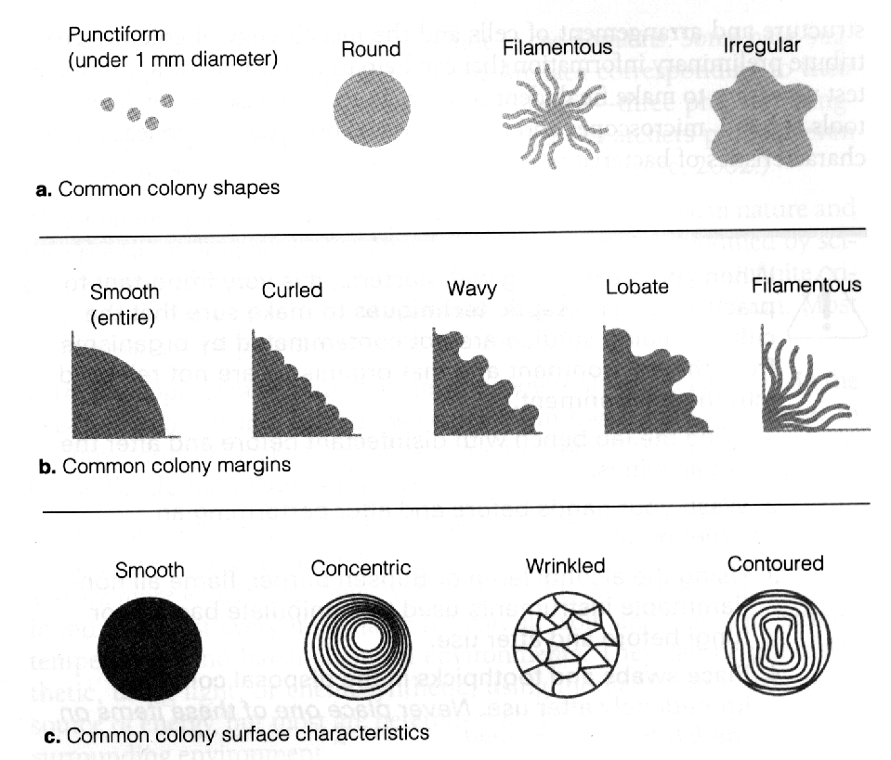

1. Note: There are no “right” or “wrong” lab results; however it Is important to be thorough and make note(s) of anything you notice that you think could change your results. For example, if you inadvertently modify the procedure by leaving the 30 minute lid off for 45 minutes, make a note of it. Sometimes such inadvertent modifications (which some may call mistakes) lead to big scientific discoveries!!

**Don’t sniff** at the colonies, or you may get an unpleasant and unhealthy snootful of fungal spores.

**Points for the lab are awarded for the following:**

* Detailed descriptions with clear observations and notes that describe in “word pictures” the things you see.
* Complete, detailed, and thoughtful answer to questions.

**When you have finished the lab, you may throw out your Petri dishes. The contents can be included in your compost, but the dishes are non-recyclable.**

**Results (4 points):**

**Day One:**

* Room One plate description:
  + 10 minutes
  + 30 minutes
  + 60 minutes
  + 120 minutes
* Room Two plate description:
  + 10 minutes
  + 30 minutes
  + 60 minutes
  + 120 minutes

**Day Three:**

* Room One plate description:
  + 10 minutes
  + 30 minutes
  + 60 minutes
  + 120 minutes
* Room Two plate description:
  + 10 minutes
  + 30 minutes
  + 60 minutes
  + 120 minutes

**Day Five:**

* Room One plate description:
  + 10 minutes
  + 30 minutes
  + 60 minutes
  + 120 minutes
* Room Two plate description:
  + 10 minutes
  + 30 minutes
  + 60 minutes
  + 120 minutes

**Day Seven:**

* Room One plate description:
  + 10 minutes
  + 30 minutes
  + 60 minutes
  + 120 minutes
* Room Two plate description:
  + 10 minutes
  + 30 minutes
  + 60 minutes
  + 120 minutes

**Answer the following questions:**

* 1. (0.5 point) Why did the instructor have you label the plates on the bottom of the dish?
  2. (0.5 point) What is a hypothesis? How does it differ from a prediction?
  3. (1 point) A reasonable person might expect some differences in the results for each room tested. What differences might you expect and why? This is your hypothesis.
  4. (0.5 point) What variables were controlled (didn’t change) in this experiment and which were not?

1. Controlled:
2. Not controlled:
   1. (0.5 point) From this experiment,

a. Which room in your home carries the least airborne bacteria and fungi?

b. Which room in your home carries the most airborne bacteria and fungi?

* 1. (1 point) Are your microbes bacteria or fungi or both? How can you tell?
  2. (1 point) List two factors that might contribute to make one room have more spores and bacteria than another.

a.

b.

* 1. (1 point) These factors you listed are “guesses” until you phrase them as testable hypotheses. List and then describe how you could test **TWO** of these hypotheses. If you like, please contact me about performing these tests as an optional lab.

1. (2 points) Choose FOUR different appearing colonies from your plates and describe them in detail. Note changes in appearance over time. These details should include colony size, speed of growth, colony morphology, and any characteristics that make you think the organism is a fungus or a bacterium. Be specific and use measurements where appropriate.

1.

2.

3.

4.

1. (1 point) What would be the effect of covering or not covering food left out on the counter overnight on the growth of microorganisms? State support for your conclusion (ie: what results from this lab make you think the effect you described is true.)

**Directions – Part Two:**

1. Label the bottom of the two petri dishes identifying them as a sample from your teeth. Appropriate labels would be TRT and T4 (which means teeth @ room temperature and teeth at 4oC, which means in the refrigerator)
2. Take a Q-tip (or another brand of cotton swab) and rub it fairly vigorously on your teeth for about ten seconds.
3. Swab the surface of the agar in the petri dishes thoroughly (like you were trying to completely cover it).
4. Repeat steps 2 and 3 on different teeth and use the second petri dish.
5. Incubate the plate marked TRT at room temperature (like the top of your refrigerator) and incubate the other plate (marked T4) in the refrigerator.
6. Label the bottom of the two petri dishes identifying them as a sample from your nose. Appropriate labels would be NRT and N4 (which means nose @ room temperature and nose at 4oC, which means in the refrigerator)
7. Take a Q-tip (or another brand of cotton swab) and swab the inside or one nostril for about 10 seconds.
8. Swab the surface of the agar in the petri dishes thoroughly (like you were trying to completely cover it).
9. Repeat steps 2 and 3 on the other nostril and use the second petri dish.
10. Incubate the plate marked NRT at room temperature (like the top of your refrigerator) and incubate the other plate (marked N4) in the refrigerator.
11. Incubate your dishes for one day, and then record the growth on each dish on the following pages. Colonies may be visible after as little as one day, or it may take several days to see anything. **Record your comments and notes on the nature of the growth on pages 7 – 8.** The following details are important to include: color, shape, smell, texture of colony (shiny, dull, glistening, filamentous…).
12. Repeat the examination of the plates on day 3, 5, and 7 (if you have time to do seven days).

**Results (4 points):**

**Day One:**

* Teeth plate at room temperature:
* Teeth plate at 4oC:
* Nose plate at room temperature:
* Nose plate at 4oC:

**Day Three:**

* Teeth plate at room temperature:
* Teeth plate at 4oC:
* Nose plate at room temperature:
* Nose plate at 4oC:

**Day Five:**

* Teeth plate at room temperature:
* Teeth plate at 4oC:
* Nose plate at room temperature:
* Nose plate at 4oC:

**Day Seven:**

* Teeth plate at room temperature:
* Teeth plate at 4oC:
* Nose plate at room temperature:
* Nose plate at 4oC:

**Answer the following questions:**

1. (0.5 point) Before you see any results from the plates write a hypothesis that might explain any similarities or differences that you might see between the different samples and the different incubation temperature.
2. (1 point) What conclusions can you make about any differences in what you see from the teeth and the nose samples?
3. (1 point) What conclusions can you make about the effect of temperature on the growth of microorganisms?
4. (0.5 point) Of what importance to **human health** was the invention of household refrigeration?